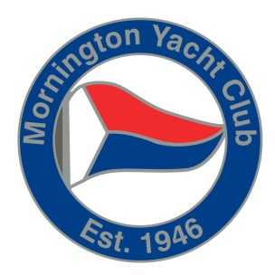
FLYING FIFTEEN GET-TOGETHER
For the old new and interested members wanting to sail Flying Fifteens on Tuesdays, Thursdays, Saturdays or Sundays.

Friday 16 October
Harbour View Room
6.30 pm have a drink
7.00 pm dinner if you want it

Because there are quite few people who are interested in sailing Fifteens this season, I think it is a good idea to have a Get-Together where old Fifteen sailors and those interested in sailing with us can meet informally. We will have a drink at about 6.30 pm, dinner if you want it say 7.00 pm and at about 7.45pm I will arrange a short discussion of a few matters relating to the new season. The main purpose of the evening is to meet the other people interested in sailing Fifteens at Mornington this year. The evening will not be a gabfest.

if you have any interest in sailing Fifteens with us this year (either as skipper or crew/own boat or club boat) please come to this meeting. We wish to welcome all new-comers and make their entry into this brilliant little boat a very happy one. Feel free to bring your spouse, partner, children or anyone else who will not cause a riot. If you cannot make it for the full evening then come for part of it.
If you are interested in coming please let me know by Wednesday 14 October (richard@satlink.com.au) so that I can arrange catering.

Richard Trembath
Class Captain, Flying Fifteens

